# **Apache Kafka**

Kafka was originated at linked in, to solve the data integration problem

Kafka was developed by jay creeps

Kafka can be used as streaming platform

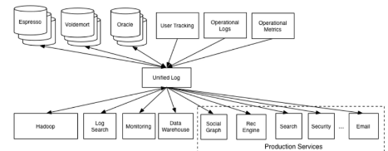

## What is apache Kafka?

Apache kafka is

* horizontally scalable (means we don’t need a single super kafka broker which have hundreads of gb’s of ram- like instead of having 1 super/master cook - we have 10 cooks in kitchen to share the load so here kafka is horizontally scalable which supports cluster of kafka brokers)
* fault tolerant – means -even if 1 broker in a cluster goes down as we have topic replication we can connect to other replication back topic in another broker
* distributed streaming platform

Apache Kafka is highly scalable (each broker can be replicated easily like replication factor of 3.. and once ur connected to any broker in a cluster means you are connected to the entire cluster) and it’s a distributed platform for creating and processing streams

Its Iike a Blood circulatory systems which will pump blood to all organs similarly it will push data to all listeners. Messages can be sent from producers to consumers in milli seconds

Example of processing streams

* To know the lorries real time positions the machines kept in lorries will continuously send their latitude and longitude data to the kafka broker, this is called stream of data because these lorries will send continuous data/ data stream to the broker

Stream is nothing but continuous flow of data

How it evolved as streaming platform from data integration platform

Components of Kafka

|  |
| --- |
| 1. Kafka Broker - |
| 1. Kafka Client |
| 1. Kafka connect – for integration between 2 components / multiple components solving above problem- like 1dstr appn is used for integration as we don’t get stream of data()because its not continuous flow of data |
| 1. Kafka Streams |
| 1. Kafka SQL/ Ksql – with this kafka wanted to become real time database. – all above 4 are open sourced whereas this is licensed |
|  |

|  |
| --- |
| 5 partitions= kafka will create 5 folders ,1 folder per partition |
| 1 partition will have many segments (segment is a file for kafka)= 1 folder will have many files |
|  |
|  |

Analogies

In kafka we have lot of topics (in city we have lot of schools-Narayana, Sri chaitanya)

Consider 1 campus is 1 topic

* Let’s take 1 topic =many partitions like each hostel ex:- Nellore pidathapolur topic will have many partitions means it will have many blocks-like Krishna, cauvery

In real time 5 partitions means for kafka 5 folders -1 folder per partition

* 1 partition will have many segments like 1 block will have many rooms -(in 1t partition rooms ranging 1-40) these same room numbers 1-40 will be present in another partition also . so these 1-40 offset numbers are unique only inside a partition
* **Storing across partition** All the incoming messages will be spread across diff partitions, like many kinds of people will come to that hostel, broker /principal will store them separately l
* like all men juniors in -A block, men senior’s in B block, girls junior’s in C block, Girls seniors in D block, Staff in another block
* similarly all the incoming messages will not be stored in a single partition/single folder, it will be spread across multiple folders
* **storing inside a partition in all segments:-** inside a block once a room (segment/file)is opened warden will fill that entire room, if max capacity of boys/girls are reached then only they will start opening/ filling another room, in real time inside a partition (in kafka terminology it’s a folder)inside a folder we have many files each file is nothing but a segment, once a file(room/segment ) is opened until max file size is reached all the messages will be continuously written to this file so inside a file all messages will be written sequentially here. Until the max capacity of that segment is reached data will be written to that segment only. if that room is filled it will start filling another room if that segment if filled it will start filling other segment
* Still there is an option ,u can specify the partition number to store that message, if u specify 1 as partition num, that message will go to that partition only
* Each message sits in a partition will have offset id, like

If u want to locate a message u must know below

1. U should know the topic name (hostel name)/folder name
2. Partition number (like block name inside a hostel)
3. Offset number

Ideas

If u don’t have access to source code use kafka connect api(source connector for producer and sink connector for consumer api)

Improve kafka

While working with kafka first decide

* Each topic should have how many partitions??
* 1 topic =how many segment
* 1 segment size? =1MB/ 100MB/1 GB??

Broker

Broker is nothing but a kafka server

A kafka cluster is nothing but collection of brokers

**Broker responsibilities**

1. Receive messages from the producers and acknowledge them
2. Store the messages in kafka log file so that even if one of the consumer is offline broker should be able to send him the message once consumer is back online
3. Deliver the message to the consumer when they requested it

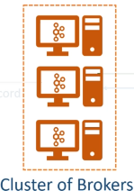

TOPIC

Its like a small data base table like all employee information in employee table- in database we will create table , in kafka we will create a topic

Like all sakshi related news in sakshi related topic , and etv news in etv topic

It is the unique name given for the data stream,

Its like unique given for your data

Topic can store millions of records, ofcourse kafka can receive million messages per second

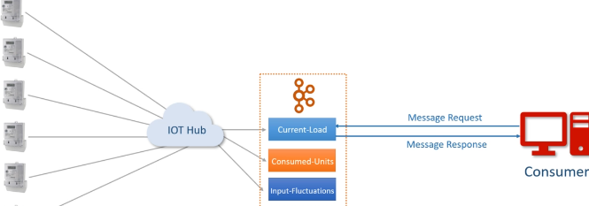

Partitions

If u create 5 partitions ~~internally kafka will create 5 folders as below

And always remember , if u don’t send partition number , then if u send the message the message will be send to all partitions, lets say if u are sending 5000 messages, some msg will go to partition-1, some may goto partition-2, some may goto partition-3 ..

But if u want all ur messages to go to partition – 1 u can do that while sending the messages send partition number too

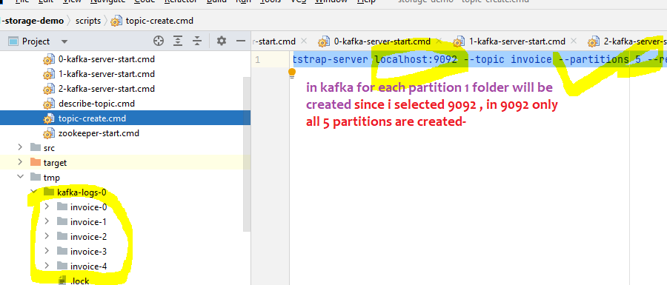

In above u saw 5 partitions are there in broker-1, if u create with replication factor 3 each partition will be created 3 times means invoice-0 will be present 3 times totally- this will be in broker 0, broker -1 too

#### Segment

Analogy: in narayana hostel each block is a partition , each floor is a segment

Topic is divided into many partitions and partition is divided into many segment

If Each segment size is 1MB, until that segment is filled it won’t navigate to other segment

As we have 3 partitions , in real time we can have 3 producers 1st producer can send data to 1st partition alone and 2nd producer can send to 2nd partition and we can have a key which decides the partition number and 1 partition can have many segment

Lets say if segment size is 1MB & if we have 3 segments for each partition 🡪 So when 1st partition receives the 1st message it will go to 1st segment only until that 1st segment fulls messages will continuously goes there only🡪 the segment file grows until the maximum segment file reached

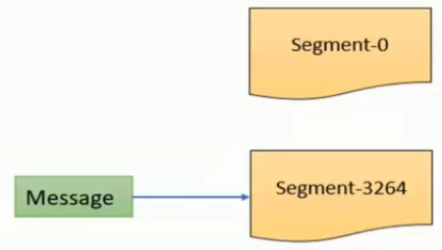if segment limit is reached then kafka will start writing to another segment, if we configure segment size is 1MB – until 1MB is filled it will writes there only, all the messages will be written here sequentially

If u observe the image all the messages are written synchronously inside a segment

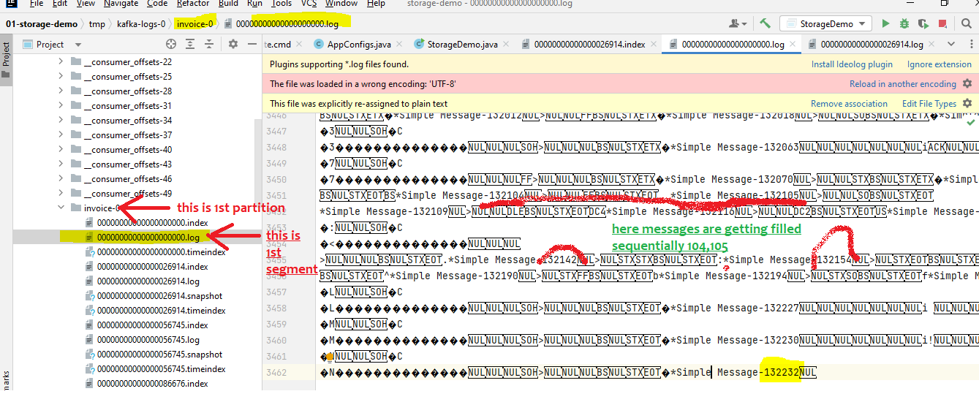

In the above understand that, inside a partition all will be written synchronously, 104,105 both are in same segment, notice that **132190 is here but 91,92 are not here they are in second partition of same topic**, only inside a partition they will be written sequentially

If huge 30 lakhs data is coming, to handle it, in 1 topic they created 3 partitions, 10 lakh records will go to first partition, and to read data from each partition we will be having 1 consumer, and 10-20 lakh records will goto second partition which will be read by second consumer

Therefore, so much of data , divide it into multiple partitions and have 1 consumer per partition

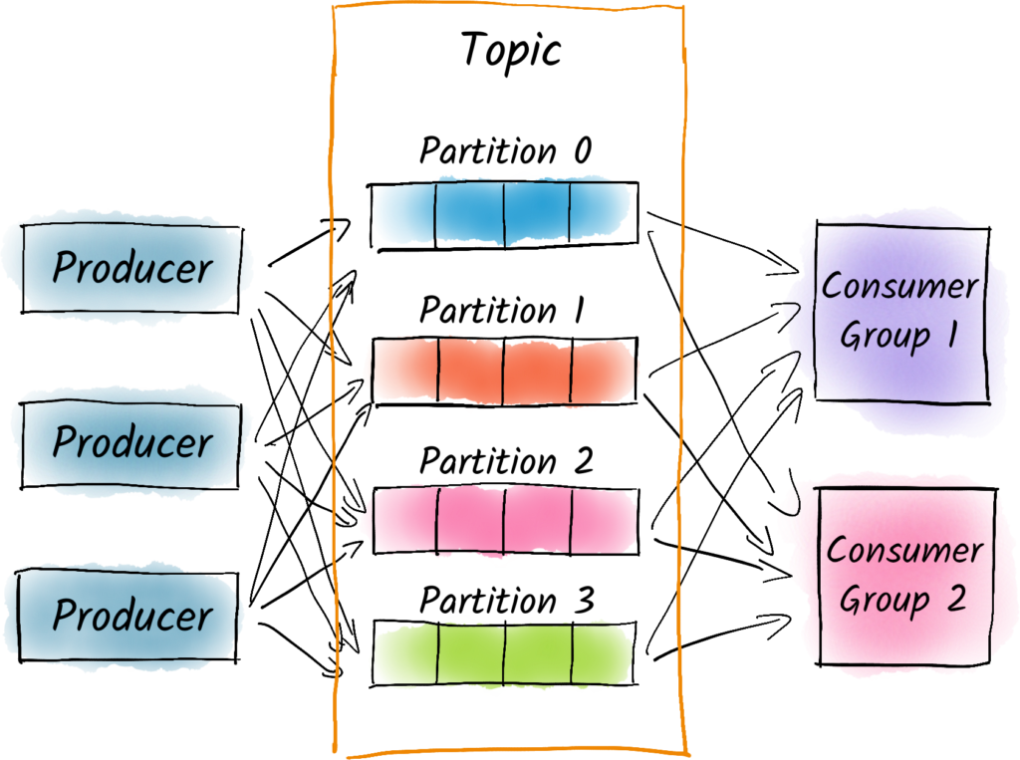

Think if every current meter is sending data (called stream (flow of data)) for every minute to a topic it can’t store in a single computer the topic would have been divided into many partitions **, each partition would get stored in separate computer** , but each partition will further be divided into multiple segments, based upon the load we should decide how many partitions we want, in case of huge data prefer more partitions

Huge load== huge partitions(20,000 partitions)== we may need huge consumers(20,000 consumers in same consumer group, therefore each consumer reads from 1 single group)

So its our responsibility to decide the number of partitions we want

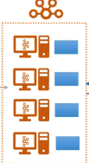

**Replicas**

C:\kafka_2.13-3.3.1\bin\windows\kafka-topics.bat --create --bootstrap-server localhost:9092 --topic **invoice --partitions 5 --replication-factor 3** --config segment.bytes=1000000

In the above command we said 5 partitions and replication factor of 3

Therefore total folders=5*3=15 folders means 5 partitions each partitions should have 3 replicas

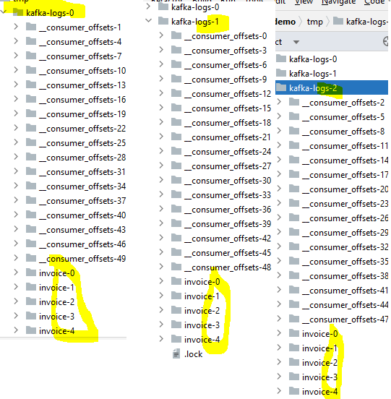

These partitions are distributed among multiple brokers

To be a fault tolerant system kafka will not store **all partitions and its replicas** in same broker if it places think if that broker went down , that’s all resiliency fails

Topic Replication factor means- if topic have 5 partitions and replication factor is 3,each partition will present 3 times totally so place duplicate copies on different machines

Partition offsets

Offset is a 64 bit integer giving a unique id to a message in a given partition

Like every person in Cinema Theater have a seat number

Since offset is not unique across partitions, if u want to locate a message u must know below

1. U should know the topic name (hostel name)
2. Partition number (like block name inside a hostel)
3. Offset number

Offset number /sequence number=in cinema theater it’s our seat number=message arrival order number

It same like in cinema theater how we get seat number , when we came to cinema theater the theater management will give us that number so that we can sit in that seat

It is the unique sequence id that is given to each arrived message in to the partitions topic by the kafka broker

Its clearly an arrival order number, when a message came broker will give

But these offset numbers are local to that partition, like another partition can also have same partition number , within each partition offset is going to start by 0 and increase by 1.

These provided numbers are immutable

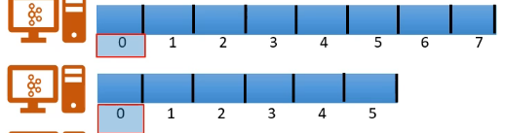

Therefore if u want to locate a message then u have to know the topic number, partition number (this partition number is mandatory because 1 topic may have many partitions),offset number

What if an big message came ?

Will it be broken and stored across many partitions and each part will have some offset number??

**Detailed explanation:-**

Analogy:- lets take a Narayana hostel, we have multiple blocks like Krishna, Cauveri, Godavari

For Krishna block /partition we have room num ranging from 1-40 (here 1-40 is offset number, consider each block is a partition

Inside a partition/Block, all offset number are unique, and for another partition same offset number will be there )

Same for Cauvery block also we have rooms ranging from 1-40 (these offset number 1-40 are same for previous partition Krishna also, so offset numbers are unique inside a partition only)

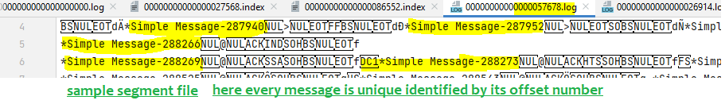

Every message inside a partition can be uniquely identified with its offset number

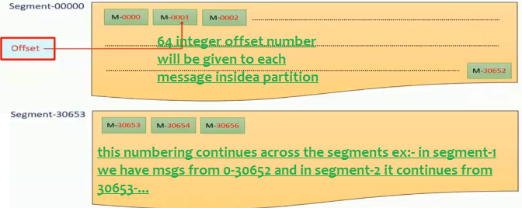

64 bit integer offset number will be given to each arrived message,

offset number will start with zero inside every partition , offsets number ranging is unique only inside a partition

1st partition- offset numb of a message starts with 0-30653(Numb in Krishna block)

2nd partition also offset starts with 0-30653(Numb in Cauvery block)

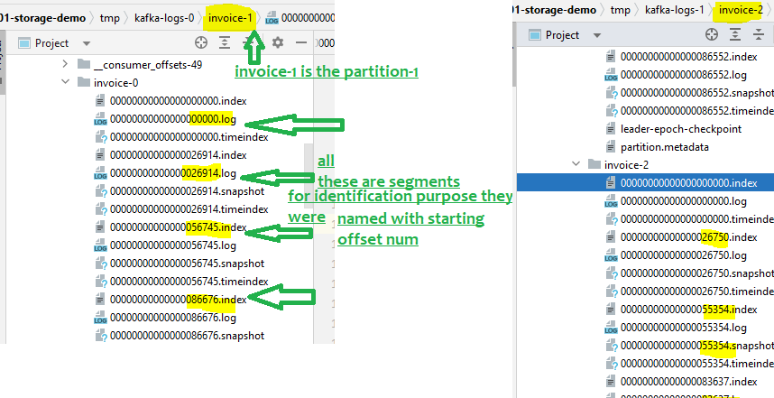

As each partition will be divided into segments

From the above understand that, offset numbers from previous segment numbers will be carry forwarded to other segment also and offset numbers are sequential across the segments inside a partition

Consumer group

If multiple consumers want to share the work, then they will form as a group and share the load, its same like podupu group , lets say if topic Is having 3 partitions, if data is coming to 3 partitions then if we create a consumer group, if we have 3 consumers in that group each consumer will read from different partitions

Zookeeper

Zookeeper will have all brokers information , kafka announced zookeeper will be retiring soon

Examples-sending 1 file to 3 consumers

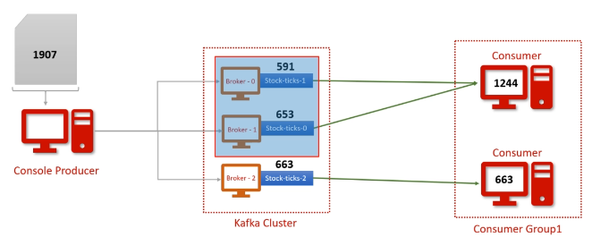

Now in this case, we are sending bulk of records 10,000 records

Producer will send the data to 3 partitions evenly , even though its single message/single file it will be split and 1st 5k rows to partition 1 and next 2.5k to partition 2 and rest to partition 3

And since we have only 1 consumer(1 consumer group) but as we have 2 consumers in same group these are workers , these will share the load among the existing partitions

1st consumer of that consumer grp will read the records from 2 partitions

2nd consumer of that same consumer grp will read data from 3rd partition

Create a new topic called stocks

.\bin\windows\kafka-topics.bat --create --topic stocks --partitions 3 –replication-factor 1 --bootstrap-server localhost:9092

Console Producer who is pushing records from excel file

Create a producer and gave a sample csv file as below then the producer will put that file to the kafka server

**Command**

C:\kafka_2.13-3.3.1>**.\bin\windows\kafka-console-producer.bat --topic stocks --bootstrap-server localhost:9092 <H1BLIST.CSV**

make sure U have the file

Create 2 console consumers who is present in same group

C:\kafka_2.13-3.3.1**>.\bin\windows\kafka-console-consumer.bat --bootstrap-server localhost:9092 --topic stocks --from-beginning --group g1**

Above command says create a topic called stocks and read from beginning and make it as a consumer under group g1

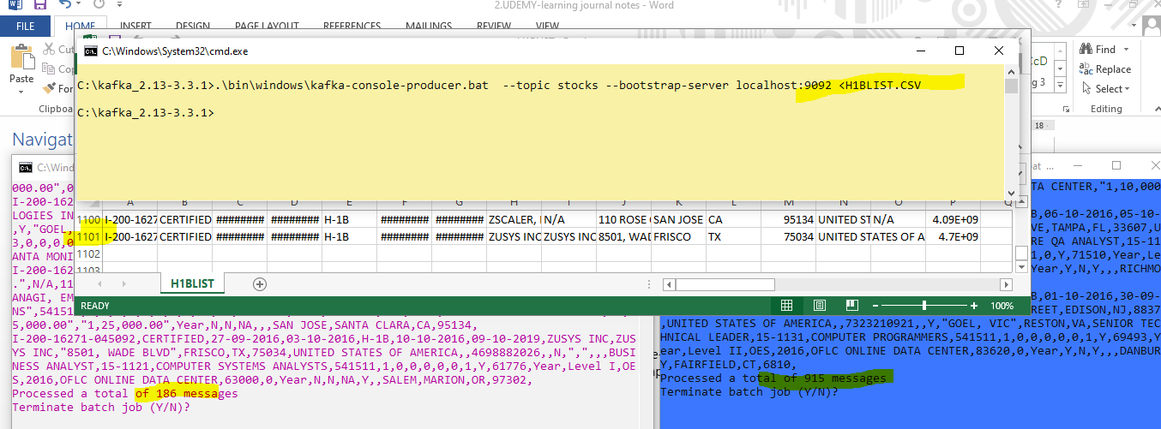

This time for 3 partitions take 3 consumers in same consumer group then load will be distributed

Among 3 consumers

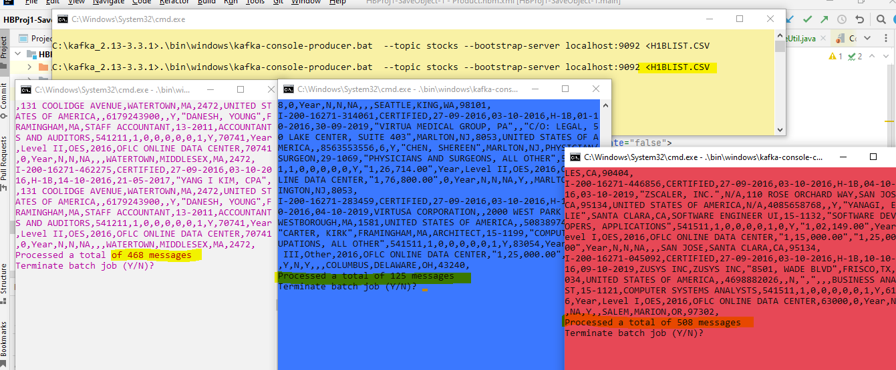

Kafka cluster

Kafka can manage hundreds of brokers in a single cluster

And every broker in a cluster will have the broker id

If a broker is active zookeeper will maintain an ephemeral (temporary) node, once the broker is down , zookeeper will delete that node from him

Kafka doesn’t encourage master and slave architecture, just one of the broker will act as a controller it will do both jobs –regular broker job and activities like when a broker dies that broker task will be reassigned to another broker (which ever broker joins cluster first ) by this controller only

At any point of time there will be only 1 controller

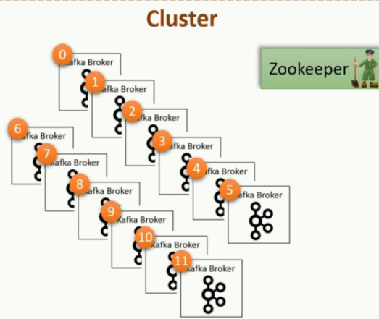

Partition assignment

Think 1 topic is having 5 partitions, but all 5 partitions will not be in same broker

In real time in production each broker will be in separate machine , since kafka is horizantally scalable those are deployed on separate machines whereas in local to get the feel we will start kafka server 6 timeson 6 diff port numbers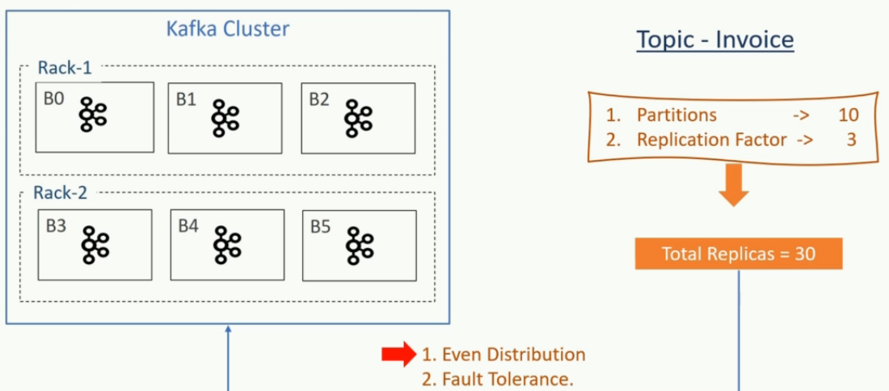

Fault tolerant system means not only if the broker goes down , it will consider the case if the entire rack which consists of many brokers goes down then also it should be able to withstand so that partition arrangement should be like that

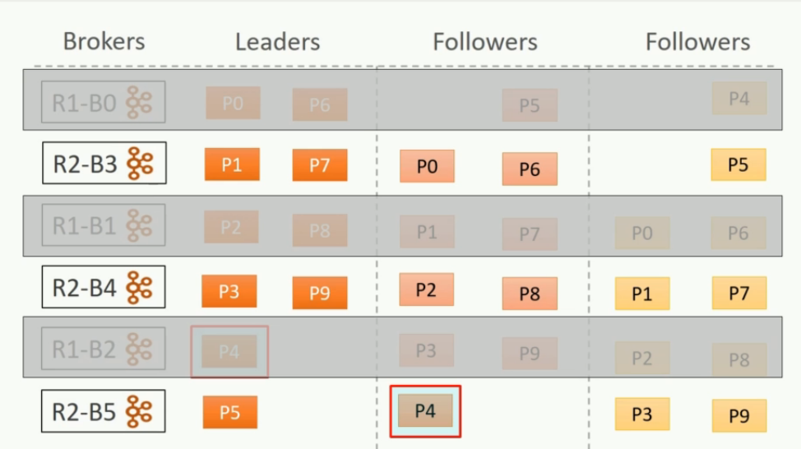

See In above even if that entire rack-1 goes down where if B0,B1,B2 all 3 goes down also it should be able to manage with the replicas available

This is how kafka will become fault tolerant

Partition follower

The follower responsibility is to copy the data from the producer and stay up to date, these followers should stay in sync with the leader else they can’t become the leader when the leader goes down

They cant get elected as the leader when they fall behind the leader

Its same like team members and team lead, all the team members should be in sync knowledge with the leader else when the leader kept resignation they cant become the leader

How can a follower stay in sync with leader?

In this case follower only requests leader and leader will some messages and follower will persists them in some segment files and again follower asks for more and leader will give some more and this process continues

How does a leader know if the follower is in sync or not?

It is based on offset number , for every message sits in a segment of a partition kafka will have 64 bit integer offset number , like how we have seat number in the cinema hall ,

Follower will ask the offset number from 0-100 and leader will give messages from offset 0-100 similarly follower will ask the next set of messages with the offset number

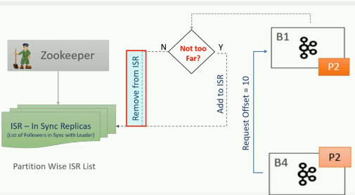

Replica will be in ISR list only when the replica is not too far behind the leader , generally the follower should ask and leader should provide the messages from the offset this will take sometime so configure it as 10 seconds, so maximum the follower can be 10 seconds behind the leader , so if the consumer offset’s are not too far from the producer then the follower will be in ISR-In sync replica list else that follower will be removed from the ISR list

#### Make more Kafka more fault tolerant

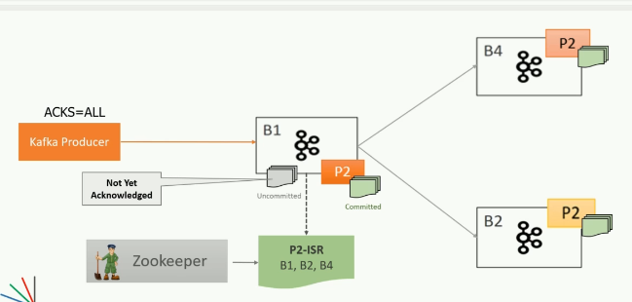

Generally the follower can be 10 sec behind the leader , lets say if all the followers are 20 sec behind the leader then no one will be in the In sync replica list suppose in case if suddenly if the leader goes down and in sync replica list is also empty then which follower should be elected as leader , if I select any other follower who is not in ISR list they all will be 20 seconds behind the leader I will face data loss because the followers are 20 sec behind means many messages they don’t have which leader have

**So if we choose them there is a data loss what is the solution?**

1. Only solution is make sure message is considered as received only when all the followers replicas also consumed , Leader should provide the acknowledgement back to the producer only when all the followers /replicas received the message, so configure kafka in such a way acks=all so that broker will send positive acknowledgement only when all ISR received it and if any ISR fails to receive the message then broker wont give acknowledgement, then producer will retry to send that message again

Minimum ISR

Minimum ISR must be set to 2

* + - lets say acks=all means broker will give acknowledgement only when all ISR’s received the messages, lets say all followers are 20 sec behind the leader then broker will remove the all followers from ISR, so ISR list will be empty, now when a message received acks=all means only when all ISR’s received the message it should send back acknowledgement , now there is no follower in ISR list other than leader, now once leader receives message it will send acknowledgement which is wrong , so always configure minimum number of ISRs in else leader only will send acknowledgement, if leader fails no backup which is data loss

The only issue is when 2 –broker+1 follower is not ready then Kafka won’t allow to insert

But still u can read a message

Producer

Producer always sends the data to the leader partition, similarly consumer always consumes from the leader partition